
EXP NO 3: CREATE A SIMPLE CLOUD SOFTWARE APPLICATION FOR PROPERTY BUYING &RENTAL PROCESS (IN CHENNAI CITY) USING ANY CLOUD SERVICE PROVIDER TO DEMONSTRATE SAAS.
DATE:
AIM:To Create a simple cloud software application for Property Buying & Rental process
(In Chennai city) using any Cloud Service Provider to demonstrate SaaS.
PROCEDURE:
step1: Go to zoho.com.
step 2: Log into the zoho.com.
step 3: Select one application step.
step4: Enter application name as property buying & rental.
step 5: Created new application as property buying & rental.
step 6: Select one form
step 7: The software has been created.
IMPLEMENTATION:
step1: Go to zoho.com.
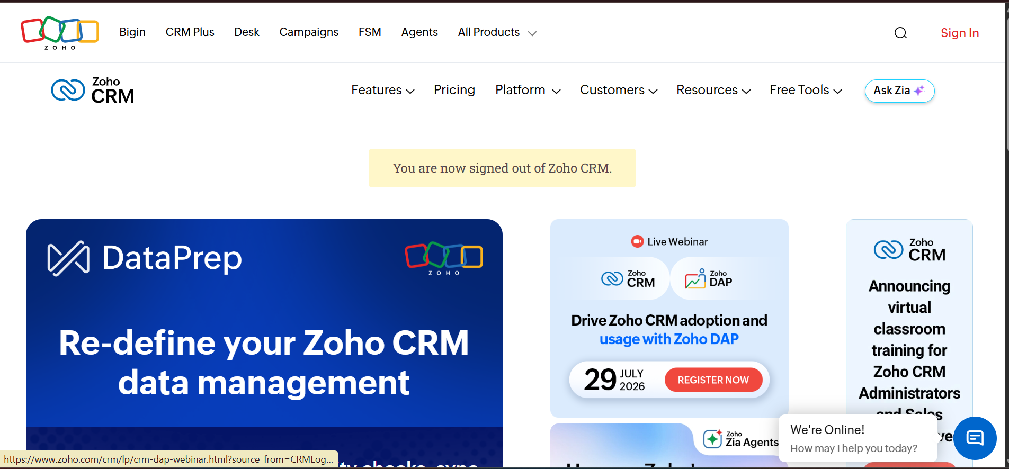
step 2: Log into the zoho.com.
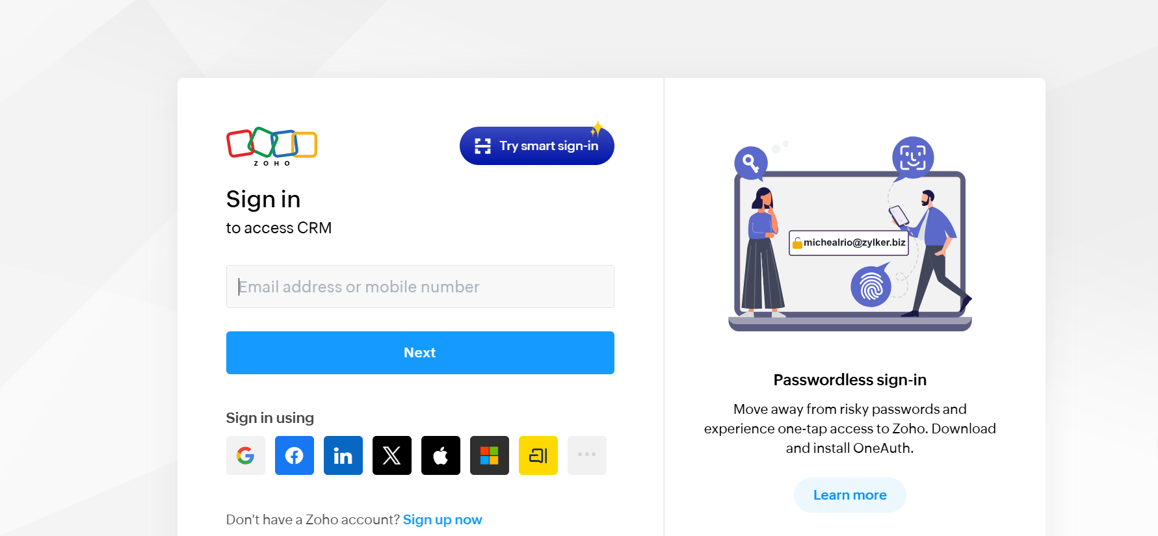
step 3: Select one application step.
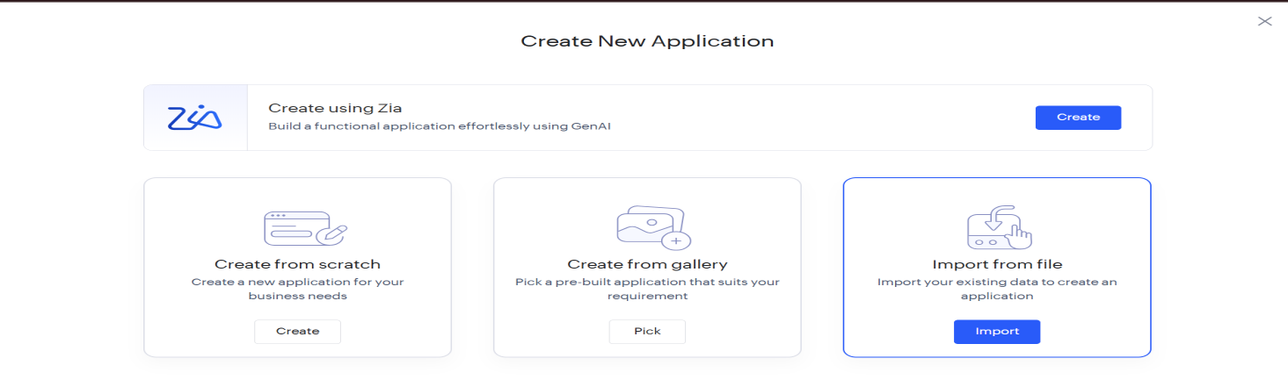
step4: Enter application name as property buying & rental.
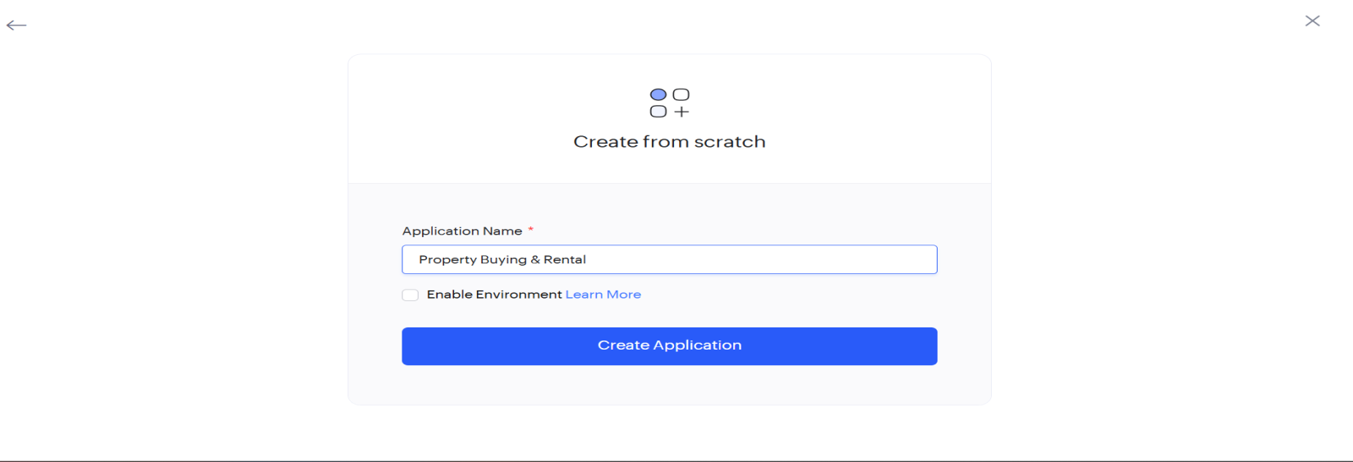
step 5: Created new application as property buying & rental.
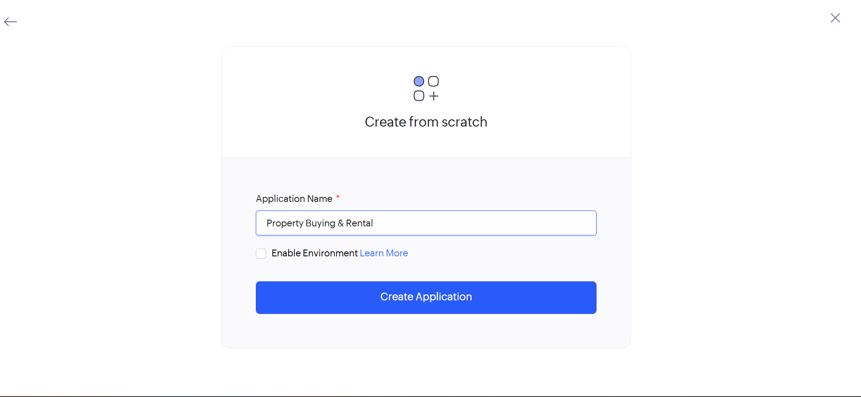
step 6: Select one form
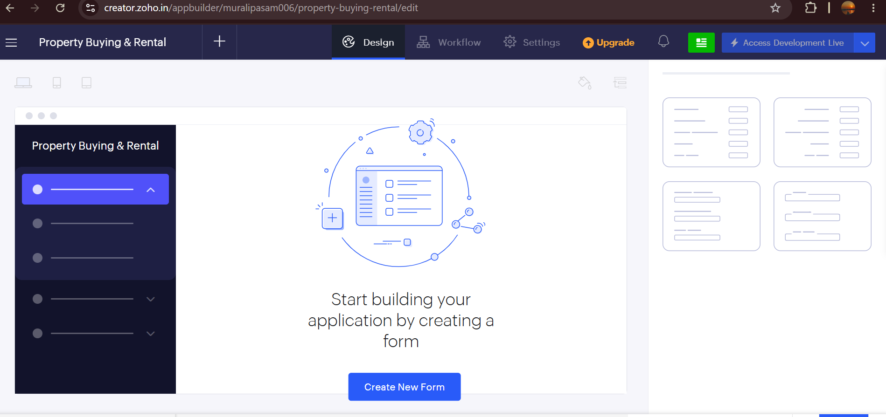
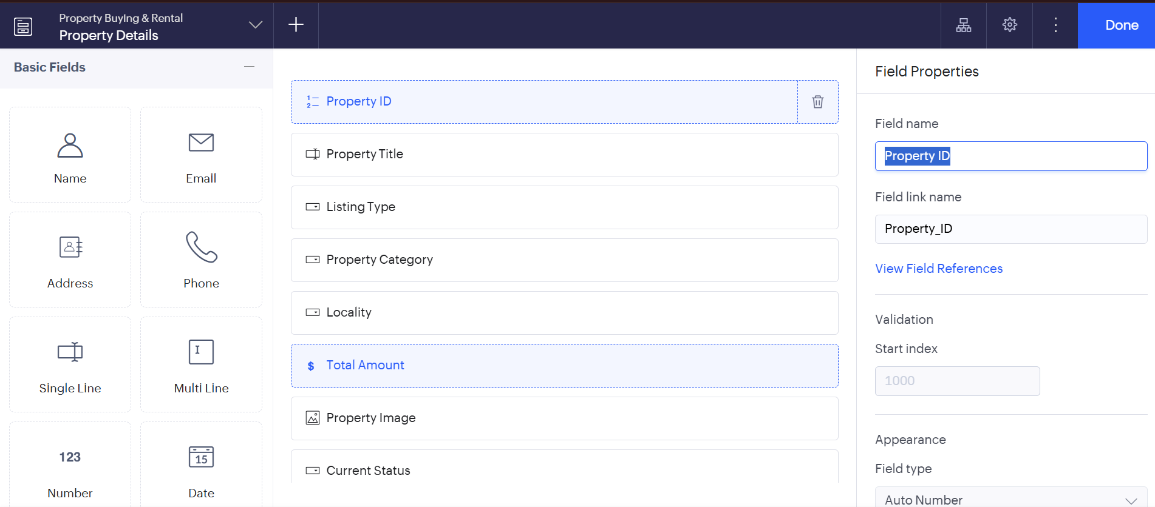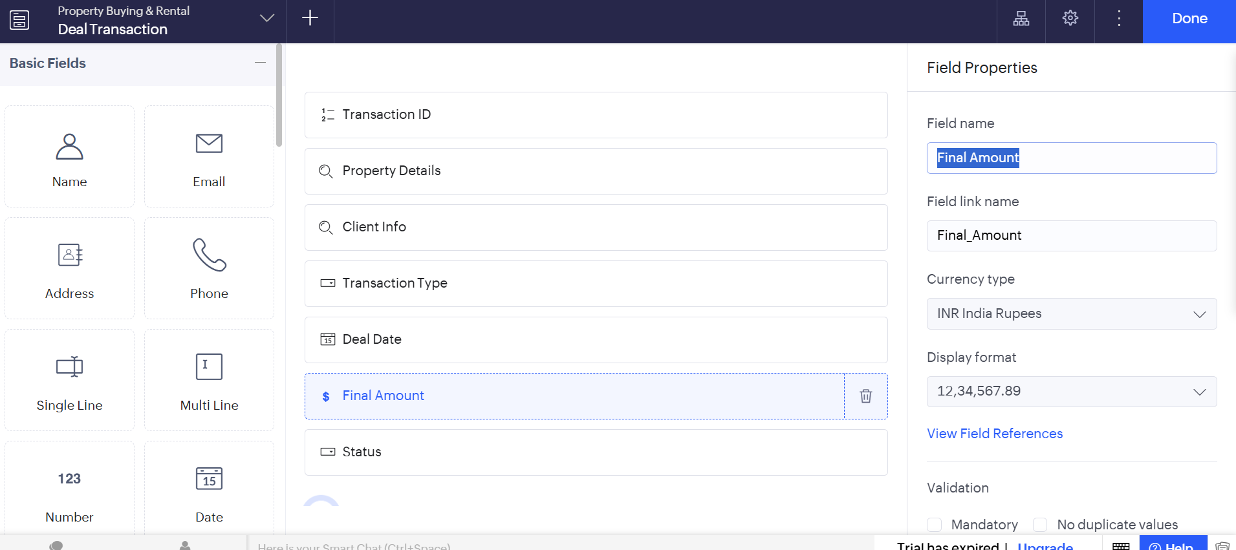
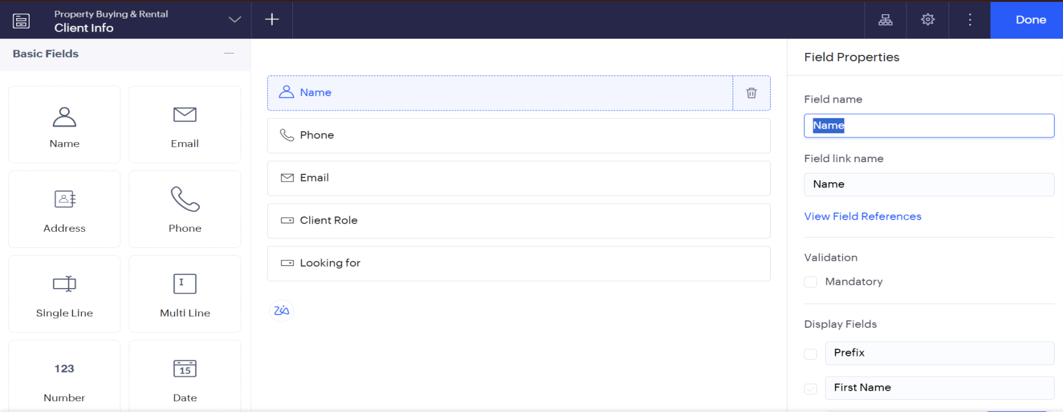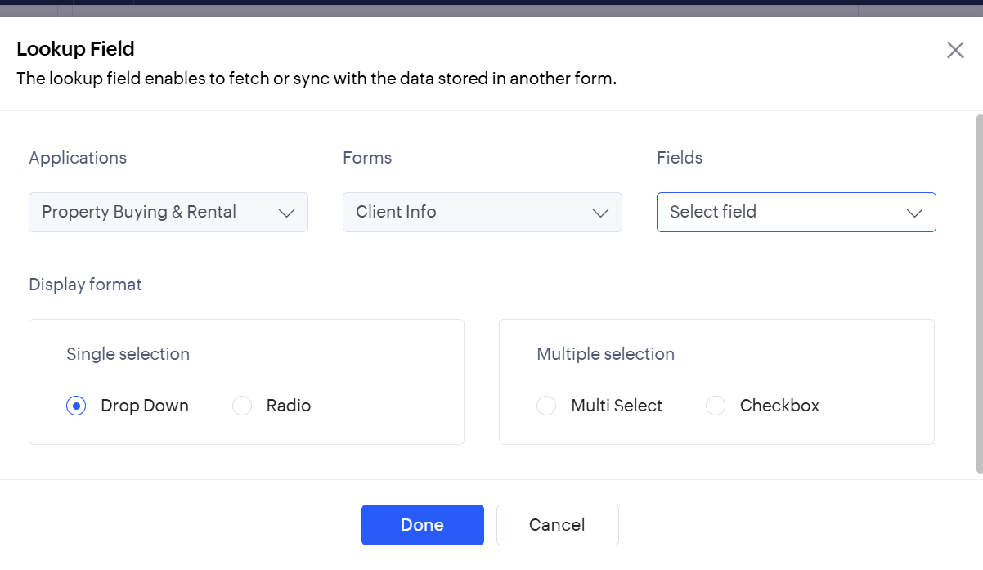
step 7: The software has been created. 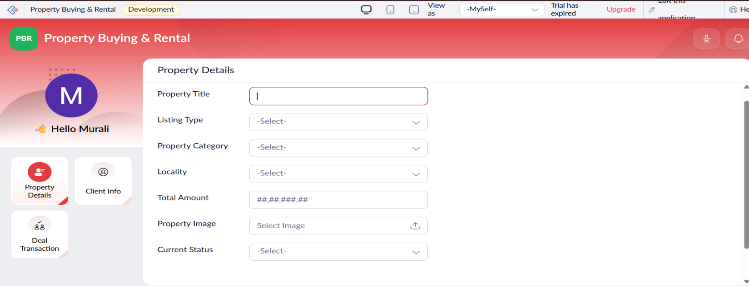
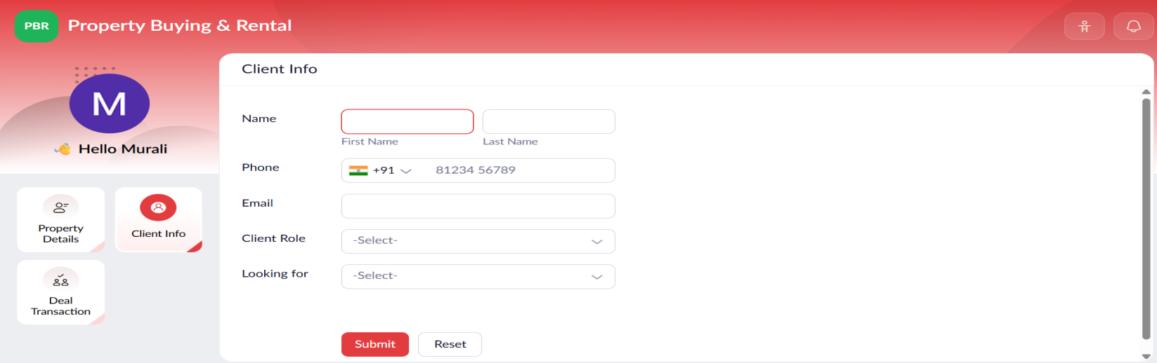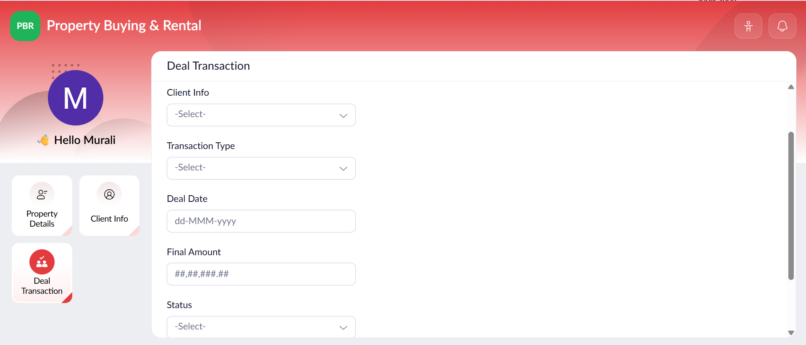

EXP NO 4: CREATE A SIMPLE CLOUD SOFTWARE APPLICATION FOR CAR
BOOKING RESERVATION SYSTEM USING ANY CLOUD SERVICE PROVIDER TO DEMONSTRATE SAAS.
DATE:
AIM:To Create a simple cloud software application for Car Booking Reservation System
using any Cloud Service Provider to demonstrate SaaS.
PROCEDURE:
step1: Go to zoho.com.
step 2: Log into the zoho.com.
step 3: Select one application step.
step4: Enter application name as Car Booking Reservation System.
step 5: Created new application as Car Booking Reservation System.
step 6: Select one form
step 7: The software has been created.

IMPLEMENTATION:

